[E141] ARM panel

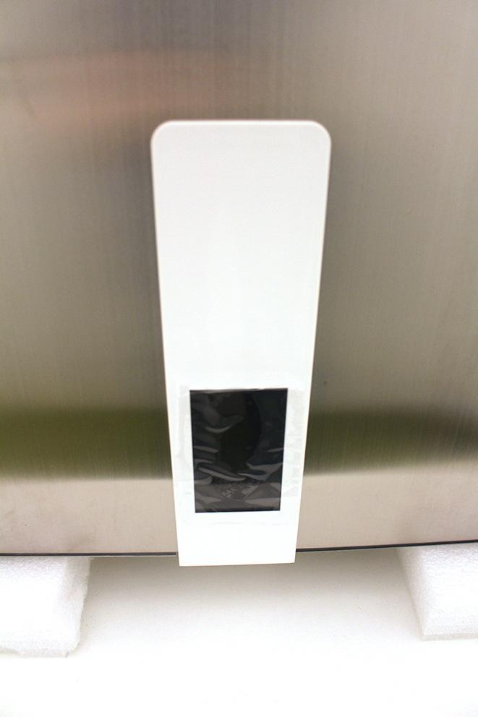

Unscrew the front panel fixing screws.

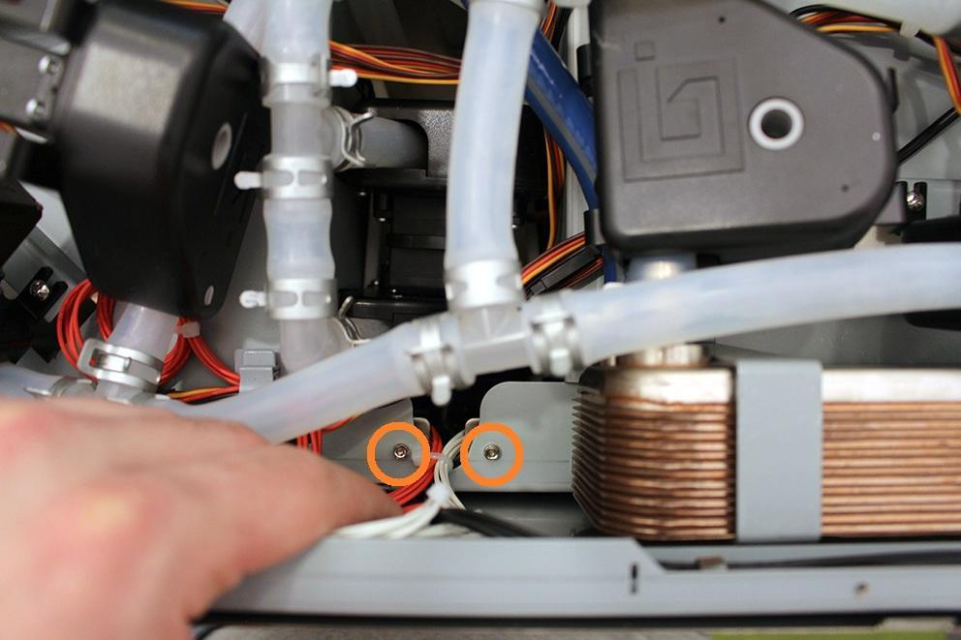

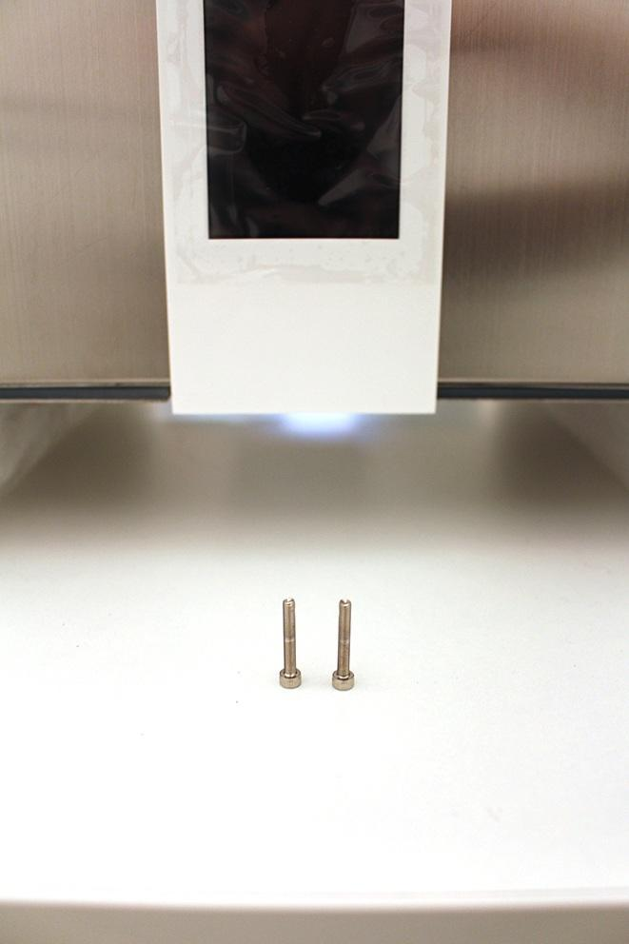

Push down the front panel to pop it out.

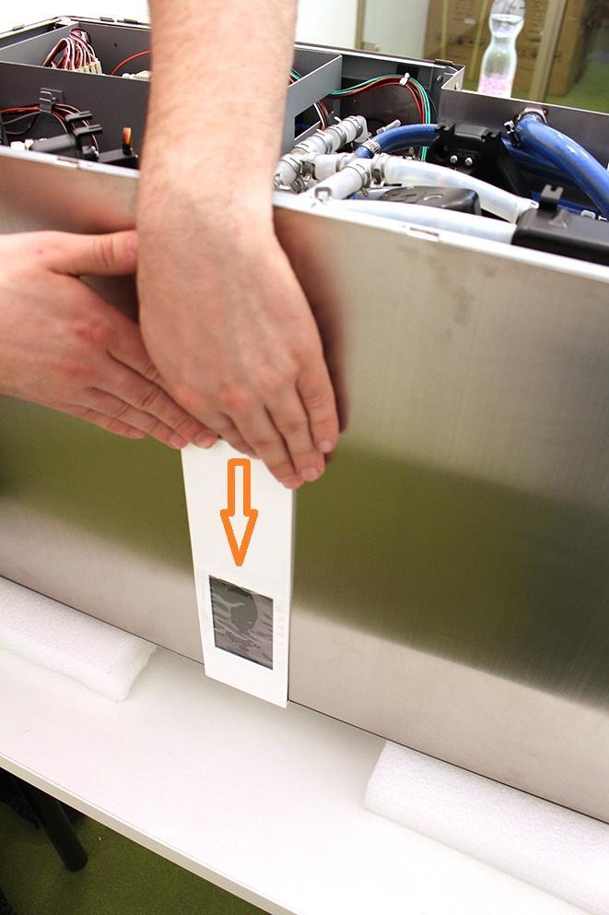

Disconnect the indicated plugs from the front panel.

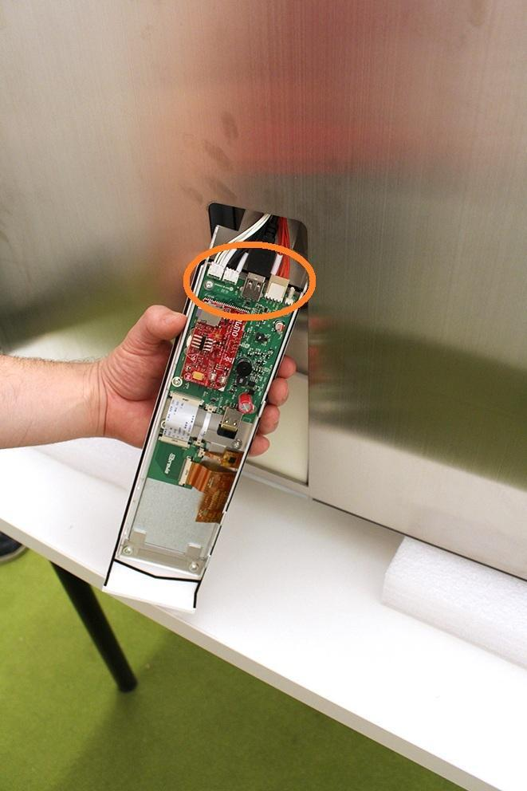

Now you can remove the front panel unit.

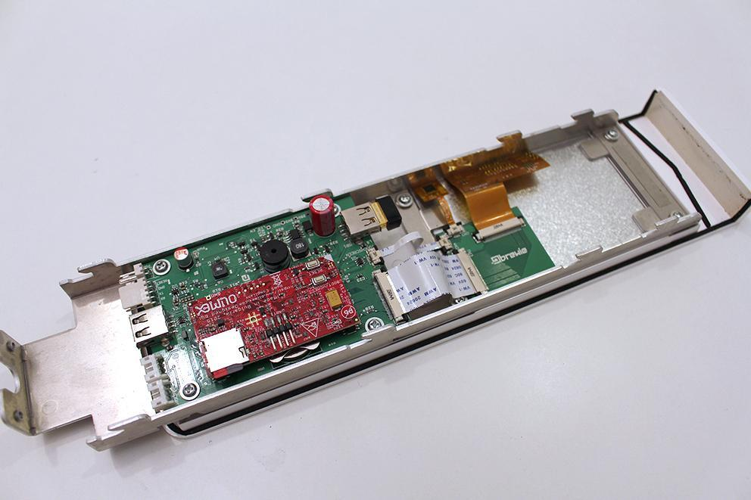

Carefully pop out the black cable lockers and pull off the cables. Cables can be damaged easily!

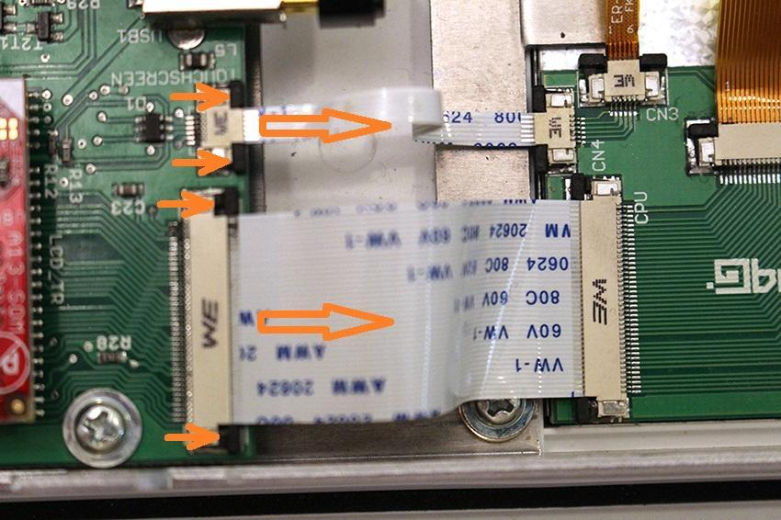

Pull off the wifi unit.

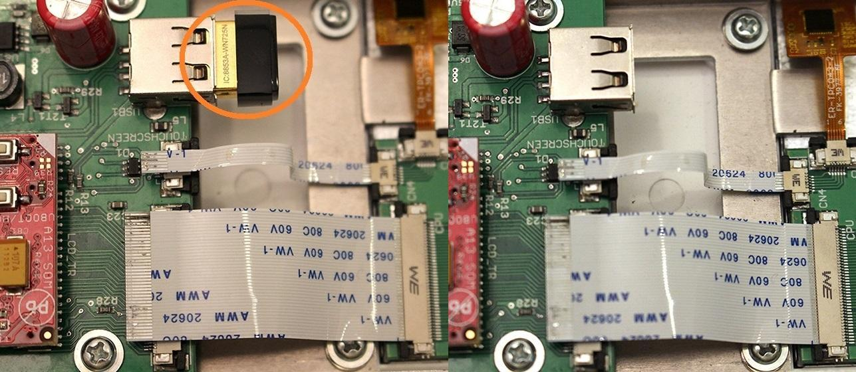

Unscrew the 4 indicated screws.

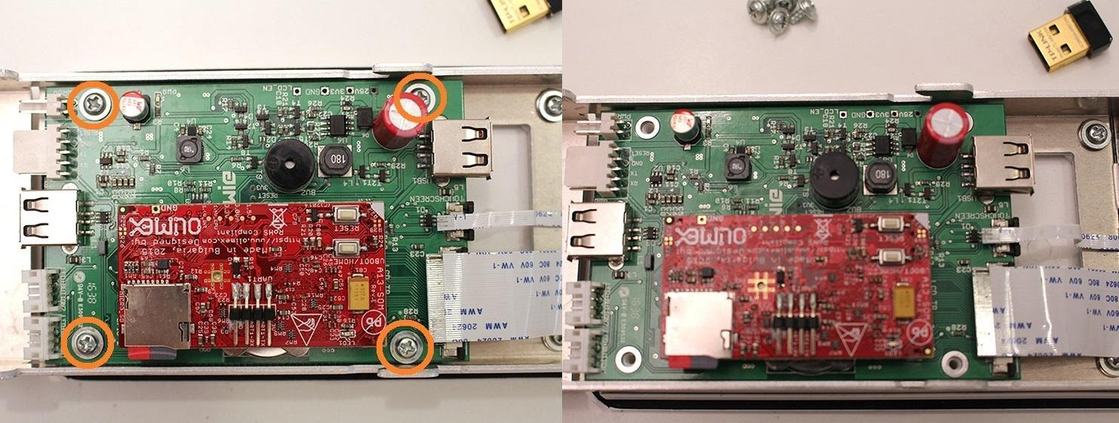

Push in the SD card to remove it.

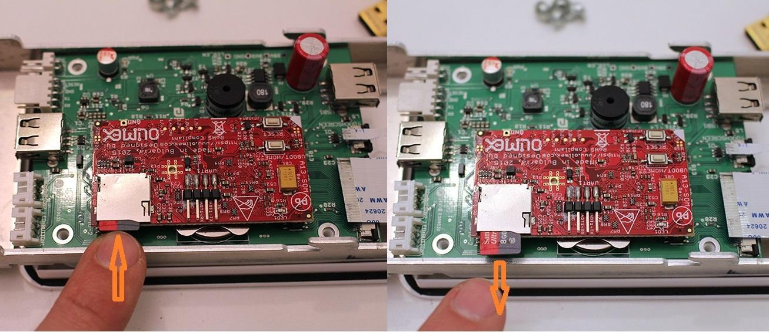

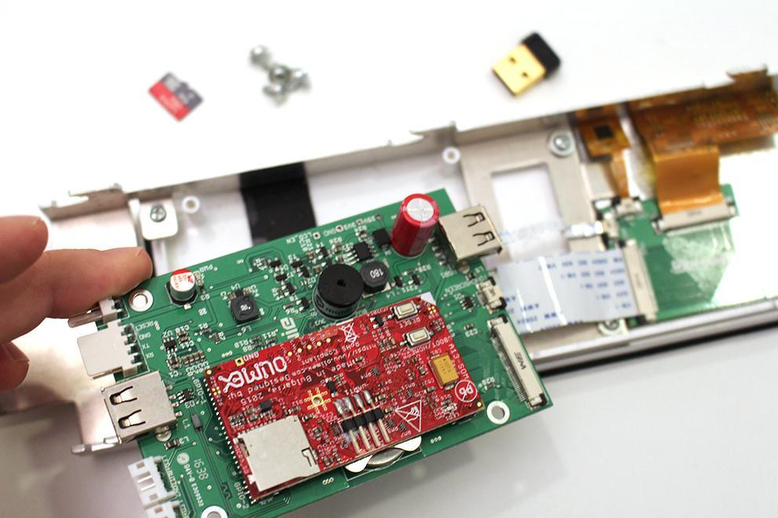

Carefully remove the Olimex panel with a precision screwdriver.

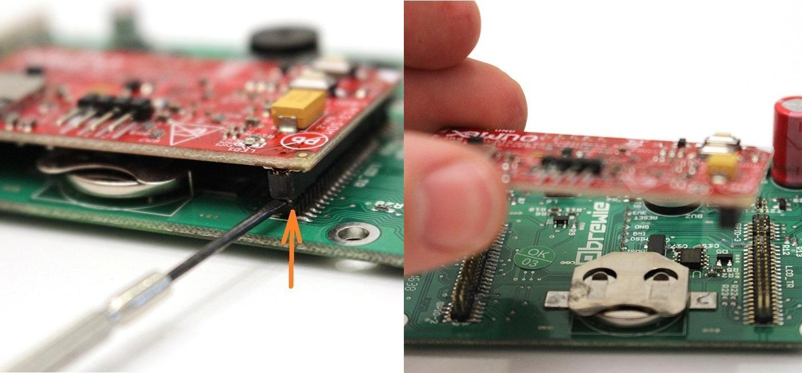

Remove the battery.

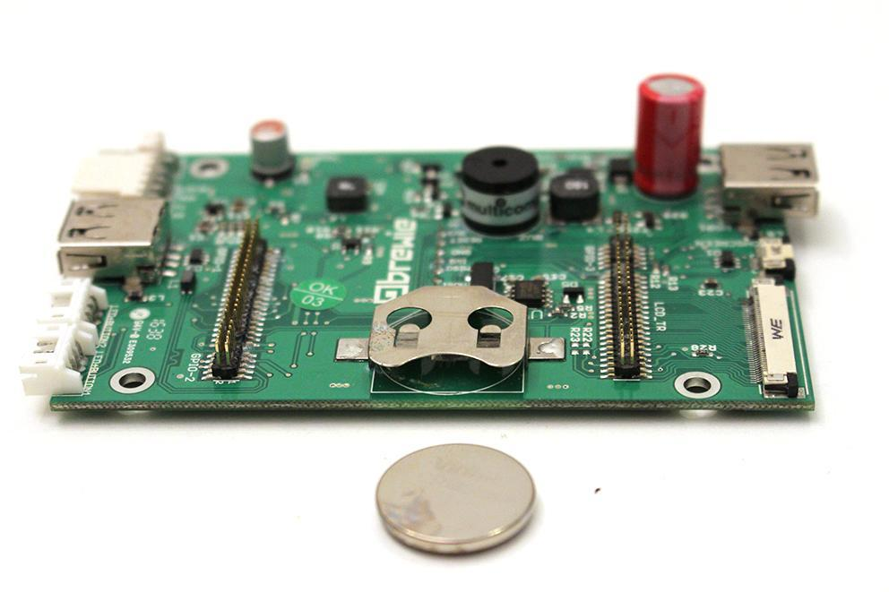

Now we have the ARM panel only.

Now you can remove the ARM panel.

The SD card belongs to the machine. You cannot change it, otherwise you have to recalibrate the temperature sensor!

Reassemble consists of the same steps in reverse.